“Online Flight Booking”

By

Jashandeep Singh

Level-6

Final Project

Table of Contents

Project Proposal 3

Goals and Objectives 3

Project Scope 3

Project Specifications 3

Target Audience 3

Project Deliverables 4

Resource Requirements 4

Project Tasks and Milestones 4

Project Assumptions 5

Project Report 5

Detail Design 6

Home Page 6

Login Page 6

Flight Admin Registration Page 7

Flights Admin View 7

Passenger Page Admin View 8

Flight Bookings Page Admin View 8

Flights Page Passenger View 8

Flight Booking Page Passenger View 9

Passenger Signup Page 9

Project Testing 10

User Manual 10

Summary 11

System Configuration 11

User Access Levels 11

# 

# Project Proposal

## Goals and Objectives

Online Flight booking is a web application implemented using ASP.Net. With the help of this application one can book their flights easily. In this application there are two types of users’ normal users known as passenger and special user known as flight admins. All users hold different rights. Flight admin can add, edit, delete and view flights, also can edit, delete, and access details of passengers and edit, delete, and access details of flight bookings. While passengers can book flights and access and delete flight bookings. New passengers can register for the application for free. The current flight admin can register new admins. The application is free and open source.

## Project Scope

Online flight booking is an online web project of 20 days. The scope of this project is to help people to book cheap and good flights easily.

## Project Specifications

* Login by admin and passengers.
* Add, edit, delete, and check details of flight by admin.
* Admin can edit, delete, and check details of the passengers.
* Admin can edit, delete, and access details of flight bookings.
* Passengers can book flights, delete and access details of flight bookings.
* New passengers can register for the application for free.

## Target Audience

The audience for this project is the people who are keen to book their flights easily. The age can be from 18 years to maximum can go 100 plus or more.

## 

## Project Deliverables

The deliverables of the project are:

|  |  |
| --- | --- |
| **Deliverable** | **Description** |
| Final Report | This is the final report |
| Coding | The coding will go into this. The executable code of the project. |
| Documentation | This depicts the documentation of the project. |
| Testing | All the test details will be covered in this part. |

## Resource Requirements

The technologies used in this project are as follows:

* Asp.net MVC Framework.
* Microsoft Word and excel for documentation.
* 64-bit processor and 4 GB or more RAM.
* Identity framework- ASP.
* Windows Operating System.

## Project Tasks and Milestones

The table below shows the Project Tasks and Milestones

|  |  |
| --- | --- |
| **Tasks** | **Weeks** |
| Research and analysis | 1-2 |
| Planning and first kick-off meeting Project Proposal document. | 1-2 |
| Design of Database | 2-3 |
| UI design | 2-3 |
| Identity framework implementation | 2-3 |
| Coding for admin and reporter | 3-4 |
| Testing | 3-4 |
| Final Documentation | 3-4 |

## Project Assumptions

While doing the implementation, the following are the assumption made:

* Admin can only register new admin if he/she will be signing first.
* The app will be free, user-friendly, and cost-effective.
* One admin and passenger will be there to login when the app will be designed and implemented.

# Project Report

#### Functional and Non-Functional

The functional requirements and non-functional requirements of this project are as follows:

|  |  |
| --- | --- |
| Users | Functional |
| Flight Admin | * Add, Edit, View, and Delete Flights. * Login/Logout. * Register new admins. * Edit, delete, and check the details of the passengers. * Edit, delete, and access details of flight bookings. |
| Passenger | * Book Flights. * New passenger can sign-up. * Delete and access details of flight bookings * Login using valid credentials |
| Non- Functional | | |
| * The project will be compatible with all browsers and devices. * Security * Fast load time of the project. * High performance * Limited access for the reporters. | | |

## Detail Design

### Home Page

This page is the main landing page of the application. On this page on the navigation menu there are options- Home, Flights, Flight Bookings, Passenger Sign-up, Login and create flight admin. Moreover, a button view flight is also present in the header images, which when clicked shows the available flights.



### Login Page

Using this page flight admin and passengers can login to the application with the help of their valid credentials.

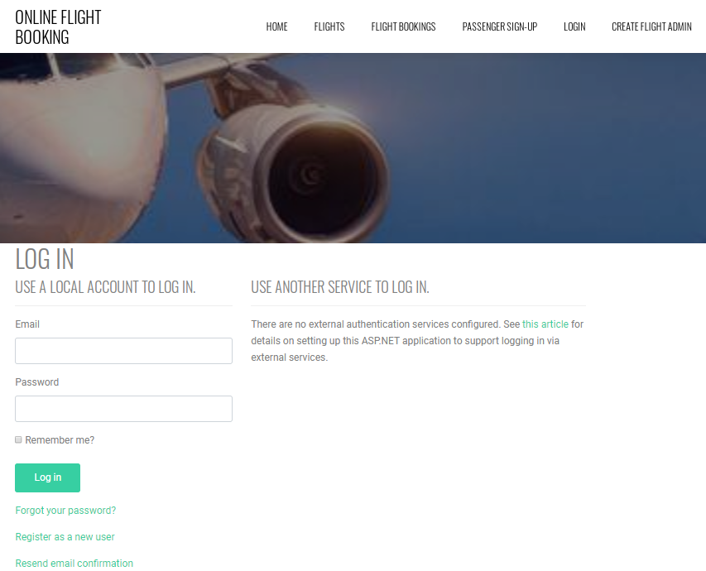

### Flight Admin Registration Page

With the help of this page, existing flight admin can register new admins for the application.

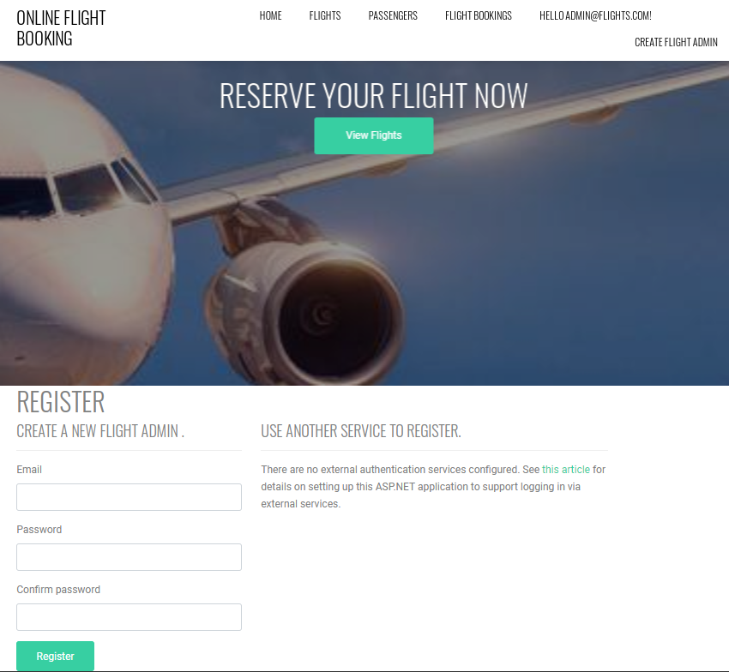

### Passenger Page Admin View

With the help of this page, admin can manage passengers by editing, deleting, and accessing details.

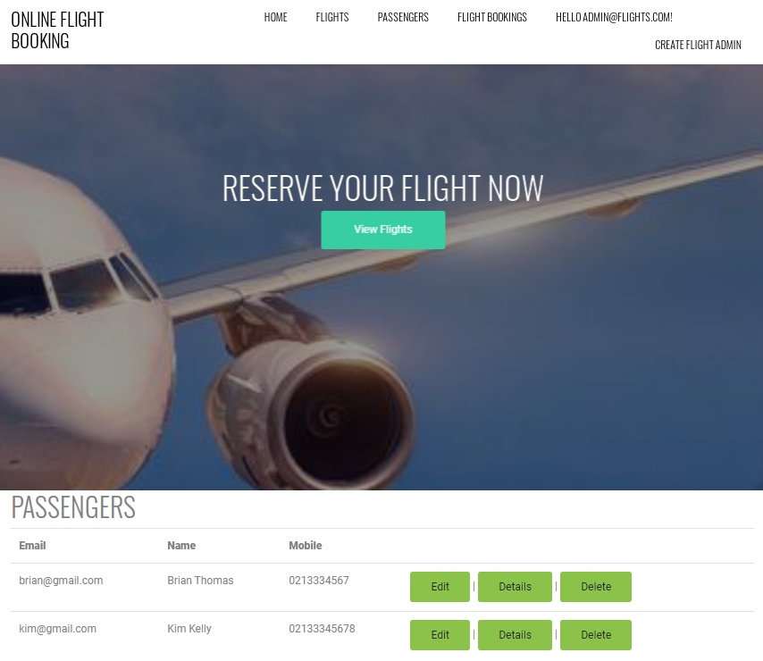

### Flight Bookings Page Admin View

With the help of this page, admin can edit, delete, and access details of flight bookings.

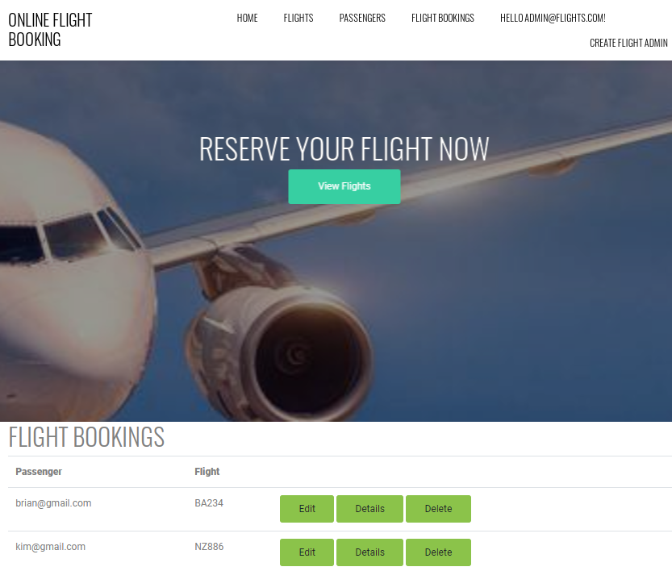

### Flight Booking Page Passenger View

Using this page, passengers can delete and access details of flight bookings.

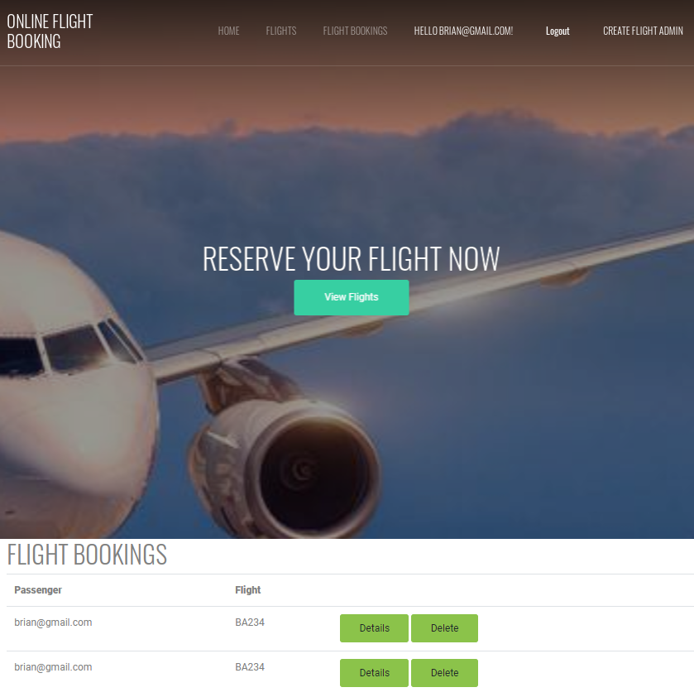

### Passenger Signup Page

With the help of this page, new passengers can sign-up for the application

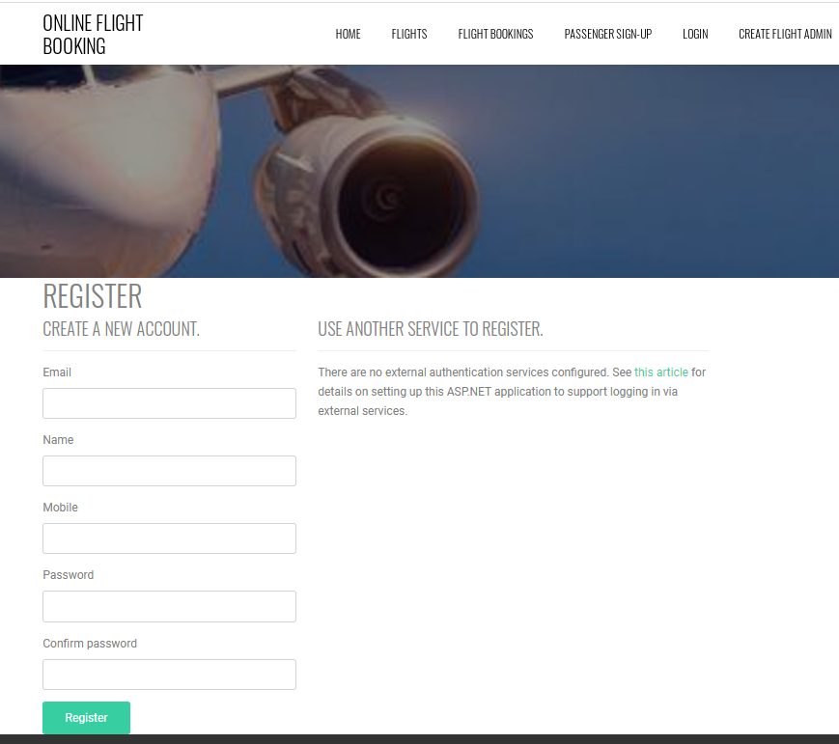

## Project Testing

Excel File Attached for Usability Testing [Online Flight Booking.xlsx](Online%20Flight%20Booking.xlsx)

# User Manual

Online Flight booking is a web application implemented using ASP.Net. With the help of this application one can book their flights easily. In this application there are two types of users’ normal users known as passenger and special user known as flight admins. All users hold different rights. Flight admin can add, edit, delete and view flights, also can edit, delete, and access details of passengers and edit, delete, and access details of flight bookings. While passengers can book flights and access and delete flight bookings. New passengers can register for the application for free. The current flight admin can register new admins. The application is free and open source.

## Summary

### System Configuration

Online Flight Booking app will be useful to find cheap flights as per the choice of the passenger.

### User Access Levels

Only registered users can access the features of the Online Flight Booking application

* **Flight Admin:** Flight admin has full access to the app can register new admins.
* **Passengers:** All passengers are having limited access and all passengers are managed by the admin. New passengers can register and book flights.